# Axie Buy Bot

There are 3 main steps in this bot.

* Step 1: subscribing ronin chain to get ‘Auction created’ transaction data.
* Step 2: using Axie Infinity API, get detailed data of Axie auction.
* Step 3: Send Buy Axie transactions with detailed data.

### Getting Data from Ronin chain

When you sell Axie, the ‘AuctionCreate’ transaction is created.

Sample url :

<https://explorer.roninchain.com/tx/0x6f91eb79517130d330e3b32a009bd47677c371c73926605e6fa7213bf7d2466b>

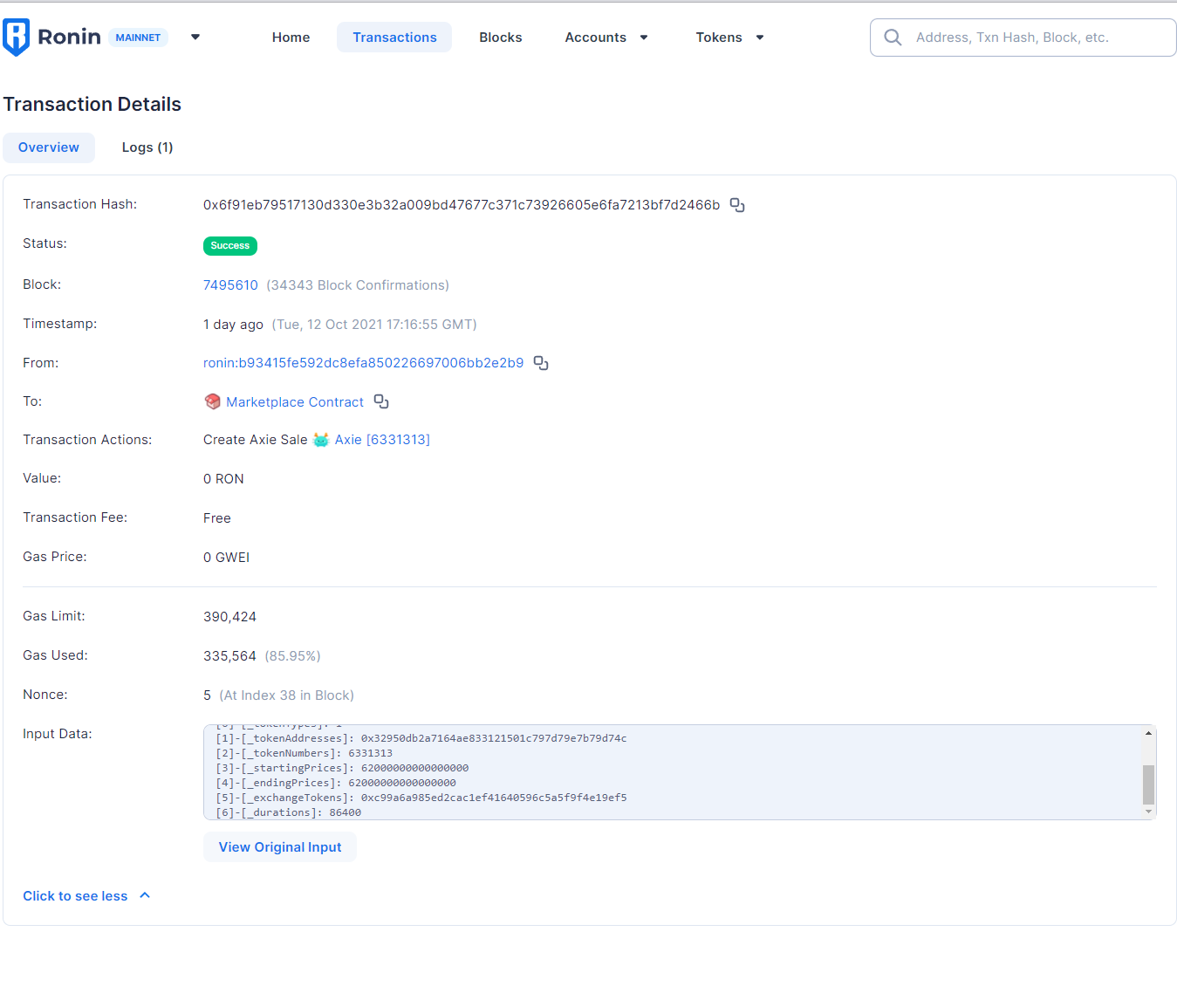

that time, We can get transaction detail data, for example, tokenID, starting price, ending price, and time duration…

So we can get AuctionCreate detailed data when the auction is created.

I added a subscribe chain module in the bot.

This module scans all transactions of the last block from the chain and filters those transactions to get AuctionCreated transaction

* First step is filtering by to address.

For getting to the address, I decode the transaction’s data. And then filter by to address is marketplace Address.

* second step is to filter by auction price.

From the transaction’s input data, I got a starting price and ending price.

And then compare with limit price value, filter transactions.

### Request to Axie Infinity API.

<https://explorer.roninchain.com/tx/0x02bd5650329e8067099f81970e005f2f9d2d365cac22b5bec6a4eecb987a8b09>

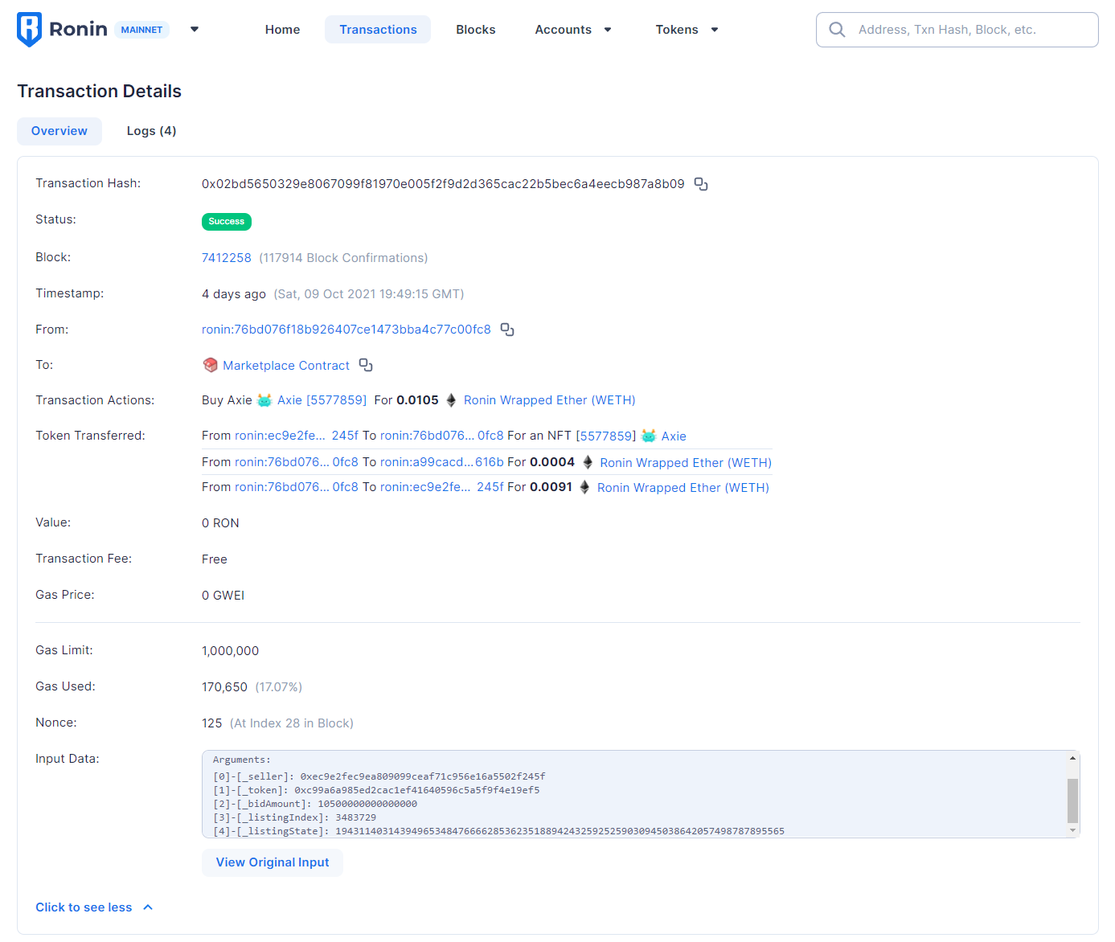

To buy Axie with web3, There must be needed 5 arguments.

* Seller address,
* weth address,
* bid amount,
* listing index,
* listing state.

Except listing state, others we can get from Market place contract.

To get listing state, we must be use API.

But I used the GetAxieDetail, method instead of GetAxieLatest or GetAxieBriefList.

As you know, the request time of GetAxieDetail is smaller than others.

request time of GetAxieLatest and Get Axie BriefList is about 1-2s, 30-31 seconds from the auction is created.

But When we use GetAxieDetail, request timeless than 0.5s, and we can get detailed data 25-28 seconds from the auction is created.

Once Auction is created, first step is detail data of auction insert to auctioned tokenID’s database, and then List of Axie is updated.

Once Auction is created, first, detailed data of auction is inserted to auctioned tokenID’s database, and then the List of Axie is updated.

It would take 7-8 seconds Axie database to be updated. In other words, We can send transactions 7-8s early than the origin bot.

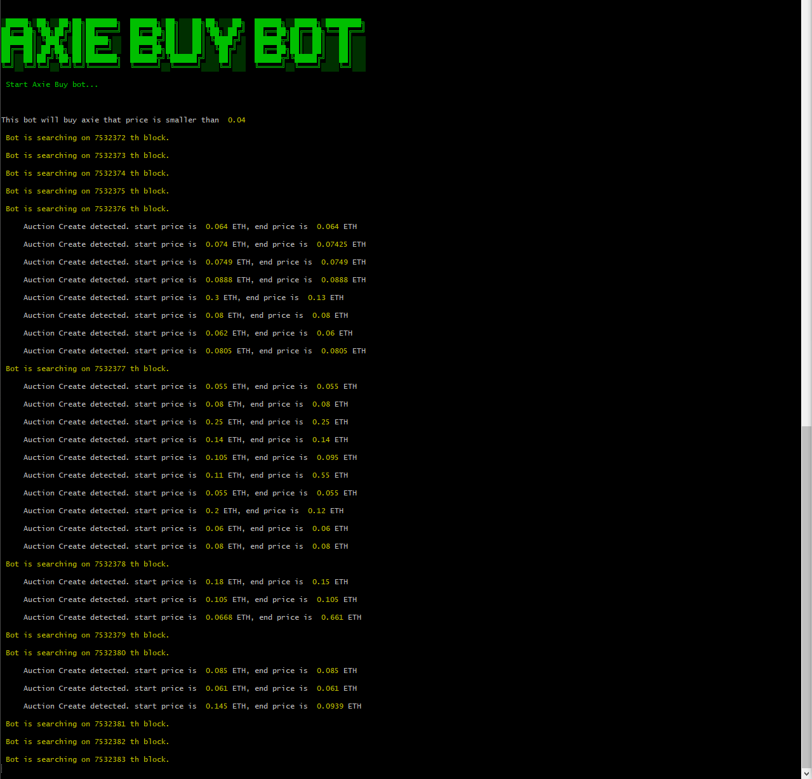

I already buy some Axie, with this bot. As you know, It can be very difficult to buy cheap Axie every time.

These are Successful buy Axis transaction’s URLs. These prices are 0.0105 and 0.01.

I think It is the very tiny price that is what you want.

<https://explorer.roninchain.com/tx/0x02bd5650329e8067099f81970e005f2f9d2d365cac22b5bec6a4eecb987a8b09>

<https://explorer.roninchain.com/tx/0x3670447d87f299d0a63a9dbbe6c17b48ea495cc2e1b2b785bb3f04bcb87b167a>